**Follow the coffee**

**Problem**:

Visiting a new city can be exciting and frustrating at the same time. Outside of the downtown core, it’s hard to figure out which neighbourhoods to visit. One approach is to try to go where locals go. But, it can be hard to figure out where these local hot-spots are. I will approximate “coolness” of each neighbourhood by the number of coffee shops in each postal code in Toronto. Any postal code with a high number of coffee shops, outside downtown core, may be worth exploring.

**Data**:

Multiple data sources will be used:

* 1. Wikipedia neighbourhoods page, which lists all Toronto postal codes, and which neighbourhoods are within each postal code

<https://en.wikipedia.org/wiki/List_of_postal_codes_of_Canada:_M>

* 1. FourSquare API, which provides number of coffee shops within each postal code

<https://foursquare.com/>

**Methodology:**

For each postal code, number of coffee shops within 1km was calculated. Even though some postal codes had more than 100 coffee shops, a limit of 100 was set. At a certain point, additional shops do not add to the diversity of the neighbourhood.

Number of coffee shops in different postal codes varied considerably. There were neighbourhoods ranging from 0 to 100 coffee shops.

Toronto map with a circle for each postal code was generated. Radius of each circle, represents a number of coffee shops in the neighbourhood. So, the bigger the circle, the bigger the coffee shop diversity.

**Results:**

Most coffee shops are in downtown Toronto, which was expected. In addition, there are 4 neighbourhoods which stood out as having an “unexpected” number of coffee shops, based on geography alone. They are definitely worth investigating. The four neighbourhoods are:

1. Humber Summit
2. Silver Hills, York Mills
3. Cliffcrest, Cliffside, Scarborough Village West
4. Humber Bay, King's Mill Park, Kingsway Park South East, Mimico NE, Old Mill South, The Queensway East, Royal York South East, Sunnylea

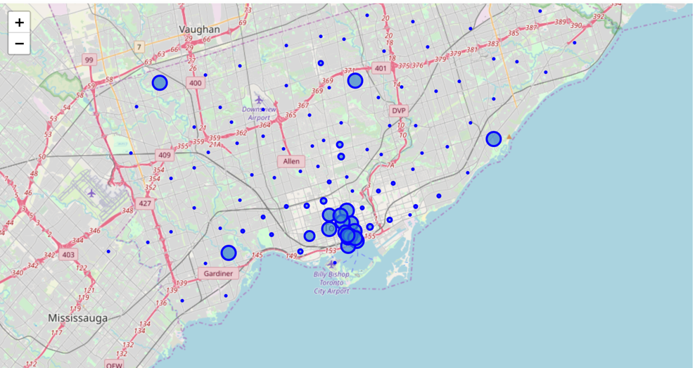

**Conclusions:**

Using this simple “follow-the-coffee” approach to explore the city may be unusual, but it may lead to finding neighbourhoods that are not overly touristy, but are genuinely authentic.

**Github:**

<https://github.com/mdanishevsky/Coursera_Capstone/blob/master/Toronto%20Coffee%20Shops.ipynb>